|  |  |  |  |  |  |
| --- | --- | --- | --- | --- | --- |
| Date | 30-Nov-22 | | | Tester Name | Mayuri Patel |
| Environment | Penfax - Test | | | Login used |  |
| Operating System | Select OS | Version: | Update: | | |
| Software Used | Select Software | Version: | Update: | | |
| Select Software | Version: | Update: | | |
| Release version | 22.4.1 | | | | |
| Title |  | | | | |
| Test Type | Regression | | | | |
| Test Scenario | Process a lump sum payment with no regular payments | | | | |
|  |  | | | | |
| Expected Results |  | | | | |
| Pass/Fail | Pass | | | JIRA# | N/A |

Describe your steps with screenshots:

Search a member who does not have any current scheduled withdrawal Instruction

Open that member Profile

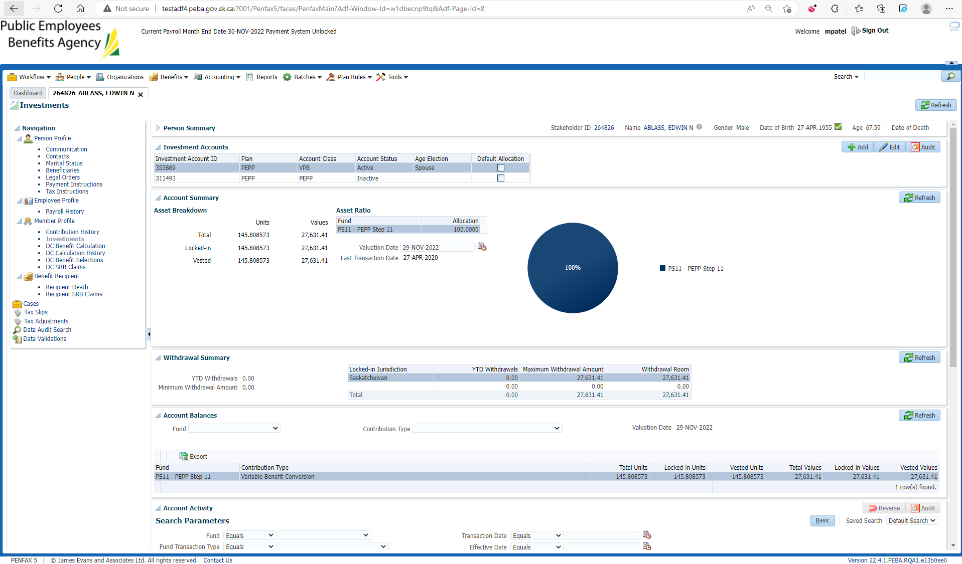

Make sure no any current scheduled withdrawal Instruction

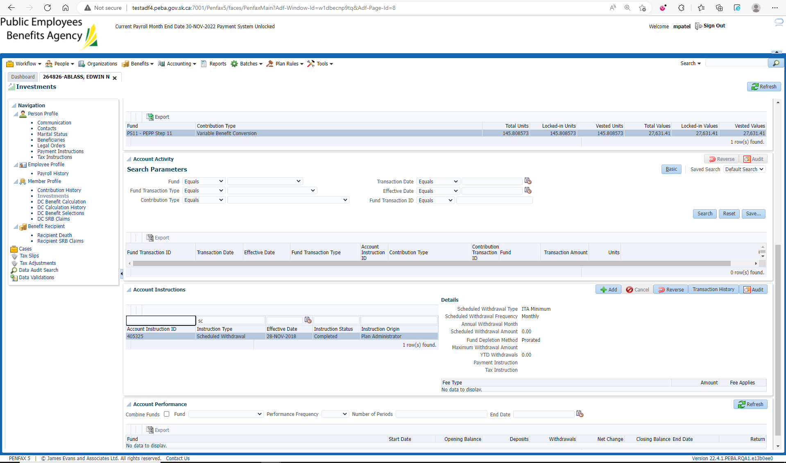

Go to DC Benefit Selection and Next

Add Allocation by dollar amount and Save

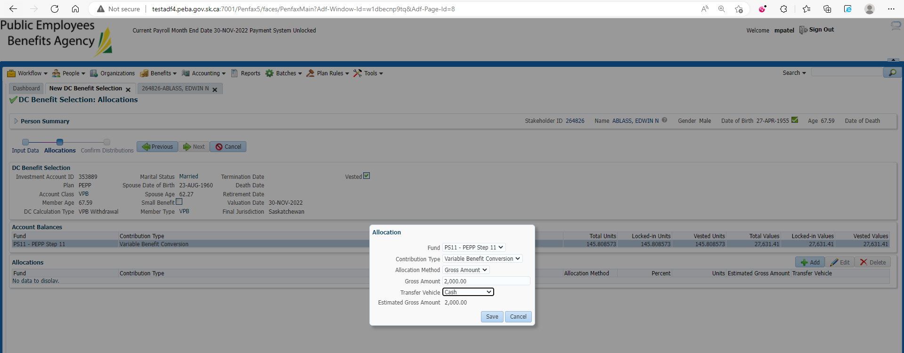

Submit for Approval and Approve it

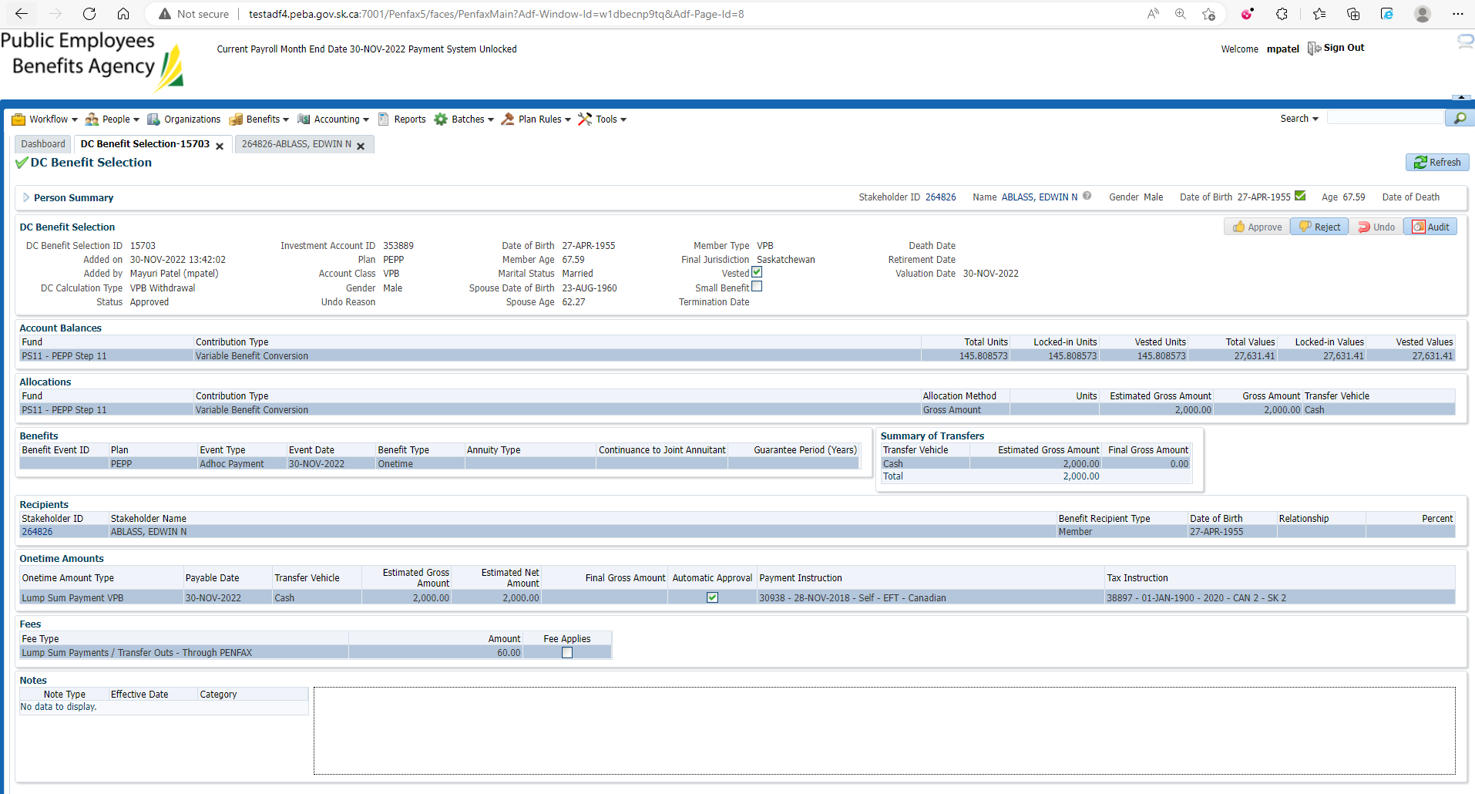

After Overnight PIT Batch

Open that member profile

Under Benefit Recipient🡪 onetime Amount tab

It is processed

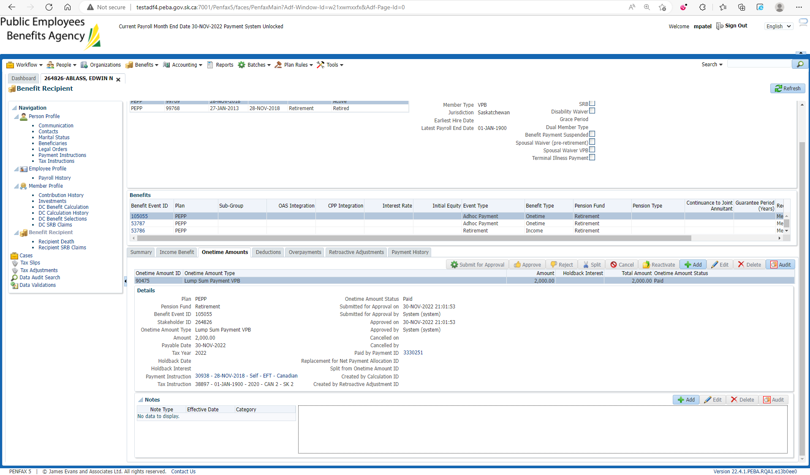

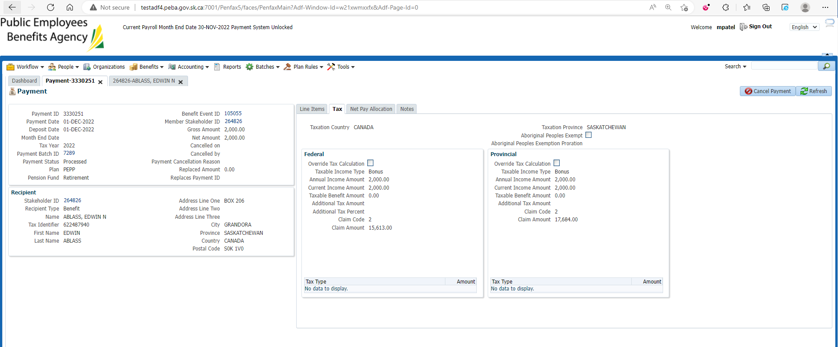

Go to Communications under Person Profile

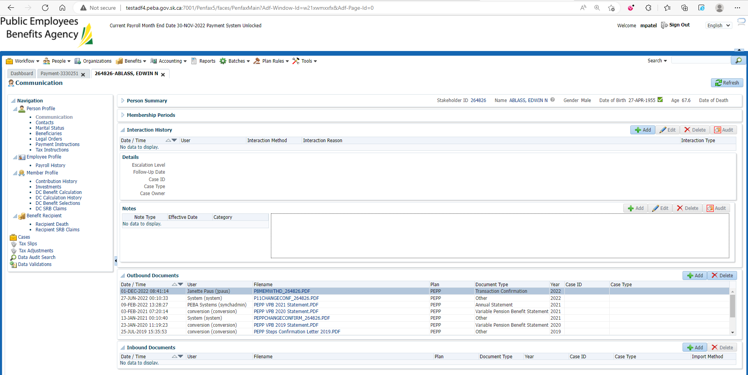

Download & Open PEPP Member withdrawal Letter

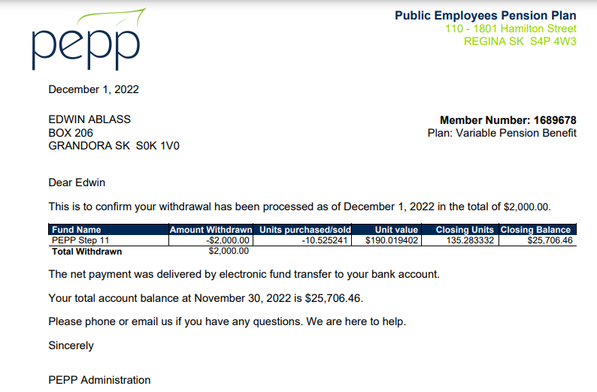

Check the Valuation Report. Go to Batches -> Batch Processes. Search with “PEPP Valuation Report” as Batch Process Type and open the very first record in the list (batch processed a day before).

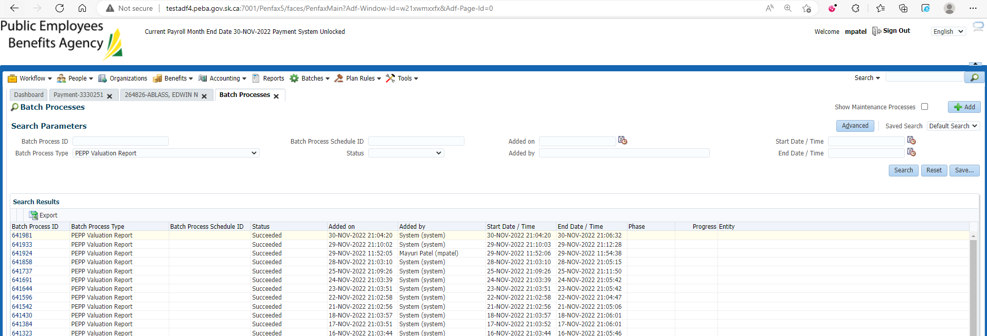

Go to Files tab and open VPB valuation excel

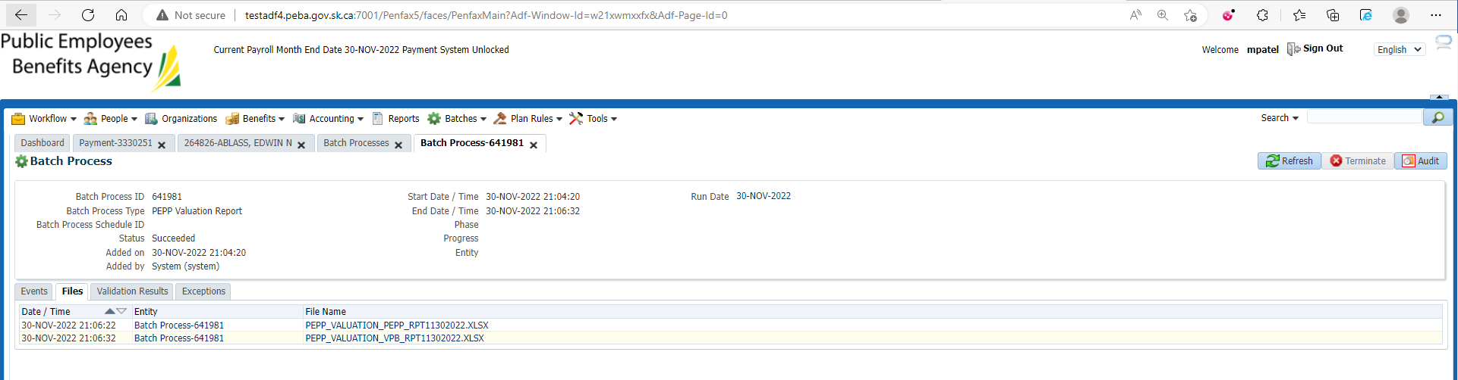

Section Seven

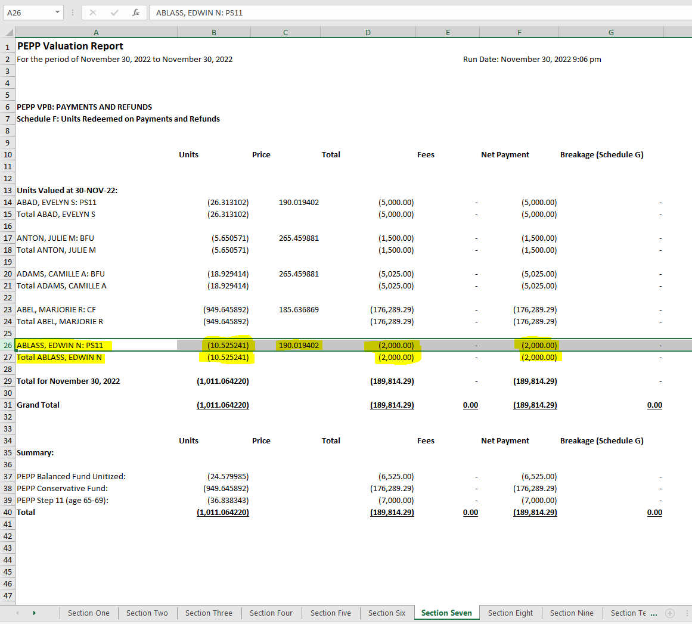

Same steps as above followed for processing through Penweb

